2022-2023 Course Catalog
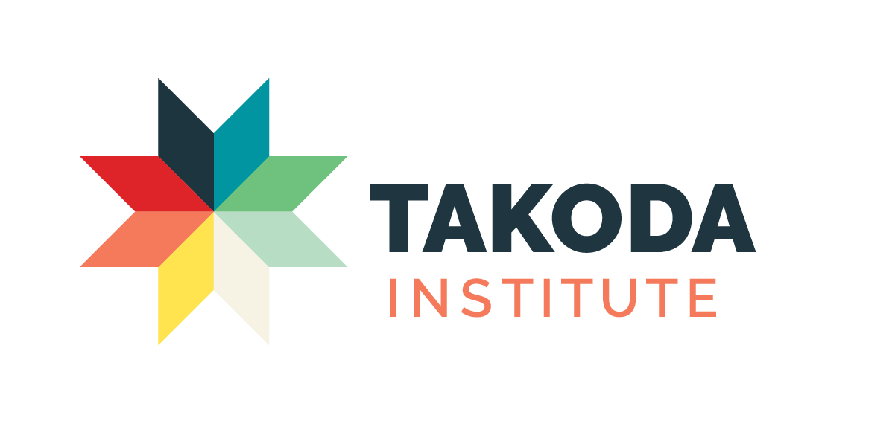

A Division of American Indian OIC, Inc., Minneapolis, MN
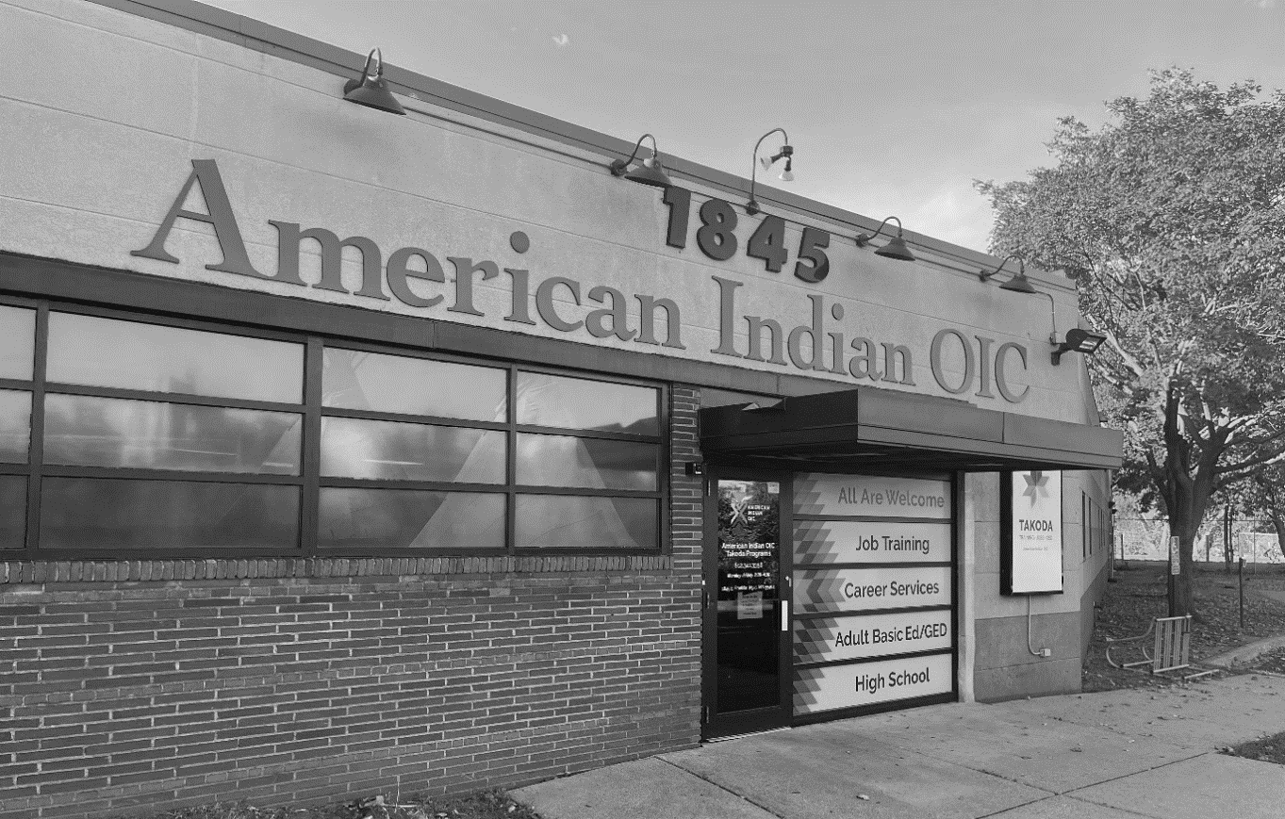
October 4, 2022

Contents

Subject Starting on page
Admissions and Enrollment 2
Testing 2
Programs of Study 4
Course Descriptions 6
Student Progress and Completion 10
Goals of the Agency and the Students 11

Policies concerning Add, Drop, Withdraw, Refunds, Credit Transfer, Student Rights and Responsibilities, Attendance, Tardiness and Make-up Hours, Extended Absence Policy, Code of Conduct, Privacy and Release of Information, Appeals and Grievances and Violence, Weapons and Security are in the Student Handbook.

The Course Catalog and Student Handbook
work in tandem and serve as addenda to each other.

The 2022-2023 Takoda Institute Calendar with Holidays

Fall Quarter October 4 – December 21, 2022. (Indigenous People’s Day, October 10; Thanksgiving Break, November 24-25) Term I ends November 11, Term II starts November 15.
Winter Quarter January 4 – March 24, 2023. (MLK Day, January 16; Wounded Knee Day, February 13) Term I ends February 10, Term II starts February 15.
Spring Quarter April 4 – June 23, 2023. (Memorial Day, May 29; Juneteenth, June 19) Term I ends May 12, Term II starts May 16.

Start dates indicate the first day of the quarter. Students may start a program at the beginning of each term. Part-time enrollment and per course enrollment are available. Some programs require a minimum number of students to begin. Contact a Takoda Institute Representative at 612-341-3358 for program information.

2022-2023 Catalog of the Takoda Institute of Higher Education

An Overview

Statement of Ownership and Purpose
The American Indian OIC is a non-profit corporation, incorporated in 1979 to train and retrain the unemployed and underemployed in preparation for employment in business, industry, and government; to secure placement of trainees in jobs, and to promote other educational and developmental purposes. (Articles of Incorporation, Article II). In 2012, American Indian OIC formally changed the name of its postsecondary school to the Takoda Institute of Higher Education (A Division of American Indian OIC).
The bylaws (revised in 2008) state that our mission shall be the training and development of skills of American Indians, but the resources and programs of the corporation shall be available to all persons, regardless of race, creed, color or sex.
It is the Vision of the Takoda Institute of Higher Education that the Institute is successfully training unemployed and underemployed people. Alumni of the Institute are employed in business, human service organizations, health care facilities, industry and government. To accomplish this, we will provide:
• Quality instruction to achieve academic, technical and personal enhancement, giving students the tools they need to keep pace with a changing world in fast-growing occupational areas. These include green industries, health care in hospitals, clinics and nursing homes or home health care, and any setting where personal health services, human services or administrative support services are needed.
• A learning environment that will instill self-respect and self-esteem and will inspire students to strive for excellence in a competitive world.
• Individual attention and encouragement to allow students to master marketable skills, exceed their expectations and achieve their visions.
• An atmosphere that supports the values and beliefs of American Indian students, and all others, while building on the individual strengths of each student.

Officers
The officers of the corporation are: Danielle Grant, Chair; Donald Flower, Vice Chairman; Charles Bolger, Treasurer; Joe Hobot is the President & CEO, and an Ex-Officio member. Other board members are Amy Koch, Summer Miller, Sheri Reimers, Reed Velo and Odia Wood-Krueger.
Information given here is current for October 2022 and until further notice. Interested persons may reach the Institute by calling (612) 341-3358, or writing to the Director of Takoda Institute, Kimberly Ben-Haim, or to the intake assistant, Justin Heminger, both at AIOIC, 1845 East Franklin Avenue, Minneapolis, MN 55404. The Web site is www.takoda.org and the fax number is (612) 341-3766.

History
The American Indian OIC began an Office Skills Training Program in May of 1981. The program grew to include full-time and part-time programs, delivered by numerous staff. This technical emphasis continues in our programs, which now include various certificates in fields leading to employment in offices, stores, hospitals and other health-care facilities, government, and non-profit organizations.

Facilities
Our campus is centrally located at the corner of Franklin and Cedar Avenues, with access to many bus routes and to the Franklin Avenue Light Rail Station. Our campus offers free parking for students and guests.
The Institute building includes class areas, digital lending library, and computer rooms. Equipment includes networked, CD-ROM or DVD-equipped computers with Internet access and USB ports, laser and color ink-jet printers, photocopy equipment, FAX and scanners. WIFI service is available.
Internet access is available to all students for use in their coursework and for general awareness of this technology. The curriculum includes textbooks, a selection of current software, and supplemental materials including learning modules and various resources including relevant events and speakers.
A laptop lending library, including Google Chromebooks and PC laptops, along with a hotspot lending library, are available as well.

Description of Programs
The Institute has one 12-week and one 18-week program leading to certificates, as well as numerous shorter courses.
Programs and the Course Syllabus: Each program has some requirements common to the other programs, as well as a special focus relevant to the individual employment fields. All of the courses listed in the two longer programs are required and must be passed for the student to complete the program.
Each course has a comprehensive syllabus which is provided to the student listing textbooks, requirements, and testing.

Admissions and Enrollment
Students will apply through the Student Services Office, which has established the following procedure for becoming a fully enrolled student. Each student will:
- Complete the Takoda Institute application & intake paperwork, including a background check and Selective Service registration review
- Take and successfully complete the Test of Adult Basic Education
- Submit documentation including identification card, social security card and additional documents required based on intake feedback.
Once a potential student has completed all the necessary steps outlined and decided which program he or she is seeking admission to, he or she may be formally admitted to the Institute.

Individual Course Prerequisites: Courses may have testing requirements and/or prerequisites. For example, Introduction to Microsoft Office must be taken before Advanced Microsoft Office. See the individual course listings on pages 6-8 for details of the course prerequisites listed just below the course titles.
Testing: Testing is required for all programs in Takoda Institute and its partners at American Indian OIC. Minimum scores and criteria designed to measure the applicants’ ability to benefit from training are established. Applicants with satisfactory test scores are formally admitted to a program of study. Testing for long-term students is given prior to each term. Other students may call the ABE/GED program at Ext. 103 for information on their testing procedures.

Required testing scores are as followed for all programs:
 | Math | Reading
Accepted | 7 or higher | 7 or higher
Accepted – mandatory Bridging with Adult Basic Education | 5.5-7 | 7 or higher
Accepted – mandatory Bridging with Adult Basic Education | 7 or higher | 5.5-7
Denied - Referred to the Adult Basic Education Program | 5.4 and lower | 5.4 and lower
Readmission Process: Former students who wish to reenter active status after withdrawing for any reason will need to start a readmission process with a Student Services Representative. For these students, as is the case with other students, all paperwork must be approved before registering for classes.
Adult Basic Education: Adult Basic Education students are those who are willing to engage in a learning contract for the purpose of skills improvement for Adult Basic Education or for GED preparation. Students testing for the full-time Institute may be referred to ABE to increase scores before being accepted by the Institute.
Others who do not wish to enroll in the Institute may also attend these classes. ABE/GED classes are available free of charge, and they are supported by the State of Minnesota.

Choosing a Program: During registration students choose a course of study. At that time, they must decide if they wish to be enrolled in one of the certificate programs or to register for individual courses only. Students must request in writing to change their program of study before the start of the next term.
Students with Disabilities: Admission requirements are the same for all students. Students with disabilities are encouraged to apply and to meet with a Career Services Representative and/or a Rehabilitation Services Counselor at a nearby site for an individual planning session for academic support services.

Appeals and Grievances and Sexual Harassment Policy
Academic Petition Process, Appeals, Quarterly Grade Resolution, General Grievance Procedures, and Sexual Harassment and Sexual Violence Policy are found in the Student Handbook.

Programs of Study

Phlebotomy (18 weeks, 19 total with break)
The Phlebotomy program is a sequence of courses designed to provide students with an understanding and technical proficiency related to the concepts, principles, and techniques required in the field of Phlebotomy. Through a combination of lecture, online coursework, and practical lab time students will demonstrate proficiency in and understanding of industry specific scope of practice, basic anatomy and physiology, OSHA safety/blood borne pathogen/infection control, preanalytical considerations, specimen collection procedures (venous, capillary, and non-blood), specimen handling and processing, patient care/customer service, HIPAA, and legal and ethical considerations
Program length is 250 hours. Typical cohort/class size is 10.
Terms are six weeks.

Requirements
Introduction to Microsoft Office Term I
Write for Work
Phlebotomy I
Phlebotomy Lab I
Medical Terminology I
Medical Office Procedures I
Customer Service

Medical Terminology II Term II
Medical Office Procedures II
Phlebotomy II
Phlebotomy Lab II
Advanced Microsoft Office

Internship Term III

Placement and Career Path
The High Demand Careers program at Takoda Institute is focused on training in high-growth areas, one of which is Phlebotomist in health care and business sectors. According to the U.S. Bureau of Labor Statistics, there is estimated to be a 32% increase in job openings for Phlebotomists nationwide.

Medical Office (12 weeks)
This 12-week program prepares the students for a range of entry level positions within the health care industry. These could include Health Information, Medical Records and Patient Services jobs. Program length is 250 hours. Typical cohort/class size is 10.

Because of employment requirements, a background check is required to enroll in this program.

Terms are six weeks.

Requirements

 | Introduction to Microsoft Office |  | Term I
 | Write for Work
 | Medical Terminology I
 | Medical Office Procedures I
 | Advanced Microsoft Office |  | Term II
 | Medical Terminology II
 | Medical Office Procedures II
 | Customer Service

Placement and Career Path
In the general area of Health Care Support occupations, about 45,000 people are working, it is estimated, in the Twin Cities area. Job requirements usually include written and spoken communication skills, good problem-solving abilities. Patient Services Representatives, Medical Records Specialists and Health Information Technicians are projected to increase at about 22 percent over the next decade.

Takoda Institute reserves the right to cancel classes which do not meet minimum required enrollment numbers (usually 5 students).

Takoda Institute of Higher Education Courses Offered in 2022-2023
Course Descriptions for Fall term
Many of these courses are offered separately and a few virtually until further notice.

Write for Work 42 Hours

This course prepares the student to communicate orally and in writing at an acceptable standard for entry-level employment. The student prepares for communication with co-workers or customers through vocabulary building, preparation of memos and letters in various formats, and discussion of standard practices. It includes grammar and language mechanics, and it requires the student to share and discuss their work, to apply vocabulary, to use the Internet and other sources effectively, to practice aspects of data presentation and status report writing and to cite sources using the APA style.
Introduction to Microsoft Office 42 Hours

This introductory course prepares the student to use office software. The student uses a common software application to practice these skills, including the presentation program, word processing, Internet browsers and search engine, spreadsheet and database. It requires the student to demonstrate these skills individually and share their results.
Advanced Microsoft Office 42 Hours

This course prepares the students to use Word, Excel, and Access at a production level. The students learn to create, use, inspect and monitor worksheets and document files, and to apply the features appropriately to a task. It requires the students to demonstrate these skills, to create documents and workbooks, to filter and sort data, and to discuss the topics.
Customer Service 42 Hours

In this course, students will explore the foundations of customer service that are integral to any organization. Using concepts of both technology and engagement, students will learn how to ensure that the customer/client/patient experience is delivered effectively– whether it is locally or around the world. The student surveys and discusses opportunities to influence improvements in external and internal customer service, whether face-to-face, at a call center, chat line or through a Customer Relationship Management (CRM) application. The student practices making a good first impression and builds their soft skills such as active listening and empathy.
CompTIA IT Fundamentals 48 hours
This course provides an introduction to component identification and the installation, configuration, maintenance, and troubleshooting of PC hardware. In addition, this course teaches the relationship between computer hardware & software, computer networks & peripherals, virus protection, disaster recovery and maintenance planning. Students who successfully complete this course will be able to proceed to the established pathway to the A+ certification.
CompTIA A+ 60 hours
125 hours: 40 hours lecture, 60 hours lab and 25 hours out-of-class assignments
This course builds on the existing user-level knowledge and/or experience with technology including desktop and network hardware, operating systems and other peripherals. The objective of this course is to provide the student with a well-defined regimen to succeed in the CompTIA A+ certification examination. Prerequisite: successful completion of IT Fundamentals.

CompTia N+ 60 hours
This course is designed to cover the foundations of networking including Local Area Networks (LAN) and Wide Area Networks (WAN) technology, and how communications are accomplished in those environments. Students learn about the fundamental building blocks for a network – with protocols, topologies, hardware, and network operating systems. Students who successfully complete this course will be able to proceed as they continue along the established pathway to the Network+ certification exam.

For more information:
Visit www.takoda.org for:
Additional classes if offered
Certification
Book information
News and special timely announcements
Graduations
Other events

Case Management 12 Hours
This course provides comprehensive case management knowledge to assist with individuals who need support to move ahead. Included are best practices for serving people with barriers. Students will practice the tools needed to help advance the goals of clients.
Takoda Institute reserves the right to cancel classes which do not meet minimum required enrollment numbers (usually 5 students).

Project Management 30 Hours
This course will cover the methodology and tools behind effective workplace project management. Students will learn the stages of project management: investigation, planning, design, production, monitoring and evaluation. Student will also gain hands-on experience developing project management tools like GANTT charts used for project scheduling and PERT diagrams used for task analysis. Project management skills have broad cross-sector appeal to employers.
Medical Terminology I 42 Hours
The Introduction to Medical Terminology course is designed to introduce students to a new language of medical terminology. Upon successful completion of the course, students will be able to comprehend a medical record report, communicate among medical professionals and have a proficient overview of medical terms.
Medical Terminology II 42 Hours
This course covers appropriate usage of medical language in written documentation. Through complete immersion, lecture, PowerPoint and daily writing assignments, students will learn to effectively communicate medical terms for hospital/ clinic documentation and patient care understanding. Prerequisite: MT I
Medical Office Procedures I 42 hours
This course focuses on front-office medical assisting. Features include systematic procedures and real-life scenarios that help readers develop critical thinking and job skills.
Medical Office Procedures II 42 hours
Continuation of Medica Office Procedures.
Prerequisite: MOP I

Phlebotomy I 20 hours
Classroom lecture teaching accurate, up-to-date, and practical information and instruction in phlebotomy procedures and techniques, along with a comprehensive background in phlebotomy theory and principles. Duties associated with the practice of venipuncture, capillary puncture, and special collection procedures necessary to perform as phlebotomists will be learned in this course.

Phlebotomy II 20 hours
Continuation of didactic learning begun in Phlebotomy I

Phlebotomy Lab I 20 hours
Practical application of theories, duties, procedures and techniques associated with phlebotomy.

Phlebotomy Lab II 20 hours
Continuation of practical application begun in Phlebotomy I

Warehouse Operator Training Thirteen days
66 hours
This training will consist of the following topics.
- Work Readiness
- OSHA 10 hour Certification
- Bobcat Skills Steel Loader
- Forklift certification
- Boom Lift certification
- Excavator certification
- Tool Cat certification
- Scissor lift certification
All of these sessions will have a live instructor and take place at AIOIC campus or offsite in at equipment sites, in a customized training program to fit our curriculum. The training will take three weeks to complete. Trainings will start at 8:30 or 9:00 a.m. every day and should go until 3:00 p.m., for a total of 82 hours. Training is free for participants, with an expected 20 people per session, and 40 to 60 per year.
The program is funded by DEED-programs, depending on the individual, and is offered free of any charges to the students. Students do not need to provide resources. Staff drives the students to the Bobcat site on Wednesday or Thursday and again on Monday or Tuesday of the following week.
The expected outcomes are to prepare the students to be safe workers, to earn OSHA 10 certification and hands-on training with a compact excavator and a Tool Cat, and to prepare themselves for employment process. This training and certification allow the students to apply with a variety of employers such as warehouses, construction sites and landscapers and present their certifications to gain entry level employment.
This is a packaged training, so all participants will be required to complete all training. All participants must be 18 years old, because of the equipment involved.

Digital Marketing 8 Hours
Students learn the primary means of formatting content for the web, email, ebooks, and smart phone apps. Gain an understanding of how the web operates and how to plan a website project. Review current trends for user interaction and mobile optimization.

Cost of Attendance
All programs and courses are offered free of charge to the students. Books are also provided.

Other Costs
Possible fees: ID replacement, $15; second background check for MO program (if missed), variable. Full-time students can expect to spend about $40 to $70 for items such as pens, pocket calculator, and similar items per quarter.
Refund policies are found in the Student Handbook.
Supportive services are available for those who qualify.

Right to Cancel

Each student will be notified of acceptance/ rejection in writing.
Any notice of cancellation received from the student shall be acknowledged in writing within 10 business days of receipt of such notice. Notice is effective on the date it was given. If you do not withdraw or contact the institution about your absence, and you have not attended your program for four consecutive days, you will be considered to have withdrawn from the school as of your last date of attendance.

Withdrawals

(More details of the procedure for withdrawal from courses are found in the Student Handbook.)

.

Student Activities
The Website www.takoda.org provides a window into the Institute and the entire AIOIC organization.
Special events, job fairs, food resources, volunteer opportunities, and the COVID Preparedness Plan are found on that site.

Attendance, Student Progress and Completion, and Students Rights and Responsibilities
The Takoda Institute of Higher Education has established policies on these areas which are found in the Student Handbook available to all students at the front desk and presented to them at the student Enrollment Event. Sections on Attendance, Add/Drop/ Withdrawal Policy, Rights and Responsibilities, Tardiness and Make-up Hours, Privacy and Release of Information, Code of Conduct, violence and weapons, and Security are included.
Internal Changes to Program: In the event that a student changes programs, only those courses whose content are applicable to the new program are accepted into the program.

Completing Requirements
Students must satisfactorily complete each required program course in order to complete their program. Also, students must pass all of the required courses to receive a certificate of completion and must also meet all other completion requirements below.
Successful graduation or completion of a course or program requires that all enrollment criteria have been met, all required assignments and/or testing out have been completed.

Certificates
The student will receive a certificate for completion in one or more of the programs, as well as transcripts of courses completed. Students starting, but not completing, a program may request a transcript of all coursework enrolled for.

Extended Absence Policy
An Extended Leave of Absence policy is found in the Student Handbook.

Academic Progress Policy

Grades
Grades are determined on the basis of testing and performance, including the successful completion of activities. The minimum attendance described on the syllabus is also necessary for a passing grade. The grading system is based on the following:
Pass / Fail (P/F): P or F—P = Pass / F = Fail
70% or above—P—Pass
Below 69.9%: F—Fail
Withdrawal (after Add/Drop Period): WD—Withdrawn
Withdrew Prior To Start of Quarter or During First Week: WF— Withdrawn Not Failing
Incomplete: - or I—An Interim Grade up to 3 months
Transfer In/Test Out: TI/TO -- Passing

Records are kept and grades are reviewed with each student at regular intervals, and grades are assigned each term.

Incompletes
The grade of incomplete (“I”) may be assigned when a student’s work is of passing quality and represents a significant portion of the requirement for a final grade but is incomplete for a good cause as determined by the instructor: good cause may include any item listed in the mitigating section of the Student Handbook. Moreover, some rules govern the use of “I”s. Incompletes must be approved by the instructor and filed with the Office of the Register. Additional information on the incomplete policy is found in the Student Handbook.

Satisfactory Progress
The Academic Affairs Council and additional warnings (Academic or Behavioral), as well as Minimum Requirements for Enrollment and Student Corrective Action Plans, are found in the Student Handbook.

Goals of the Agency and the Student
Staff of the Takoda Institute of Higher Education wants to help each student to achieve the goal of obtaining marketable job skills and employment, as well as further developing an awareness of the need for ongoing education. We intend to assist each student in breaking down the barriers which might keep a student from achieving these goals.
Students should feel free to discuss problems that might interfere with attending classes, or with getting and keeping a job, with the staff.
Takoda Institute of Higher Education staff will make every effort possible to help students solve these problems. In addition, at least one staff member (the Academic Advisor) will be assigned to discuss the academic expectations and overall progress for that student, and to act mutually with the student in finding support structures and resources needs for completing school and moving into initial employment.
The success of each individual student is the success of the Takoda Institute of Higher Education. The students are its most important resource and product.

Assistance Toward Placement
Throughout their program, students are assisted in job skills development, employment searches and placement through their ongoing work with the Career Counselor. In addition, the following agencies also assist students in job placement: Workforce Innovations for Natives, MFIP, Minneapolis Works and a variety of local services that focus on employment placement.
Career Counselors specialize in working to place graduates in employment. Our team utilizes partnerships with healthcare, IT, business, and other employers to place graduates in fields related to their training.
Workforce Innovations for Natives (WIN is a program which seeks to empower its clients to become employable and economically self-sustaining individuals, and addresses other barriers, such as childcare, which can hold a person back from full-time employment. There is a WIN program located in the AIOIC building. This WIOA program at AIOIC serves unemployed and underemployed American Indians living in Hennepin County. (A WIOA program located at the Minneapolis American Indian Center serves American Indians living in any of 71 counties outside of Hennepin County, including Ramsey County.)
MFIP is the Minnesota Family Investment Program. MFIP is a comprehensive state, county and city welfare –to-work effort to help families become self-sufficient. The AIOIC MFIP program offers case management, career counseling, support services, and more.
Minneapolis Works assists Minneapolis residents to gain economic self-sufficiency. Supportive services such as providing bus cards, work clothes or tools can also be gained through enrollment in this program. Like most of these services, the Minneapolis Works participant must attend an orientation to be enrolled. AIOIC is a Minneapolis Works and Minneapolis Youth Works (ages 18-24) service provider. Staff in our building provide those services.
As part of these services, a Career Resource Center, which has access to various services is located in the AIOIC building. In that center, students and clients can receive assistance in finding part-time employment while enrolled and employment upon graduation.

Statement on Health and Safety Policy
This is the current guidance from the Minnesota Office of Higher Education:
This guidance offers recommendations to prevent COVID-19 transmission for Institutes of Higher Education during the COVID-19 pandemic. This document is an outline of considerations that any institution of higher education can use during the COVID-19 pandemic in developing plans for campus learning. It is meant to be flexible so that each institution can tailor their actions in a way that best suits their capacity and campus.
The level of mitigation efforts needed on campus will heavily depend on the levels of vaccine coverage on campus. Institutions should discuss ways they can monitor the overall vaccine trends on campus so they can adjust mitigation measures accordingly.
In developing these considerations, the Minnesota Department of Health (MDH) reviewed the Centers for Disease Control and Prevention (CDC) Guidance for Higher Education, the American College Health Association, recommendations from the MDH Higher Education workgroups, composed of representatives from colleges and universities across Minnesota, and the collective experience of navigating COVID-19 this past year.
Institutions should develop plans that outline communication strategies, actions, and activities that support a safe campus culture; address campus activities during the summer; prepare institutions for the fall term when on-campus traffic may be at its height; and maintain COVID-19 testing resources, contract tracing efforts, and the ability to respond to a surge on campus. For additional resources related to higher education institutions, refer to Institutes of Higher Education (IHE): COVID-19 (www.health.state.mn.us/diseases/coronavirus/schools/ihe.html). For additional information on the basics of COVID-19, visit Coronavirus Disease 2019 (COVID-19) (www.health.state.mn.us/diseases/coronavirus/index.html).
Takoda Institute has established the required plans as outlined above, takes precautions, and holds the required discussions.

Reporting Requirements:
Minnesota Rule 4605.7070 OTHER REPORTS.
It shall be the duty of any person in charge of any institution, school, child care facility or camp, or any other person having knowledge of any disease which may threaten the public health, to report immediately the name and address of any person or deceased person suspected of having the disease to the commissioner.
Statutory Authority:
MS s 144.05; 144.0742; 144.12
History: 9 SR 2584; 30 SR 247
Published Electronically: September 15, 2005
The list of illnesses mandated to be reported to the Minnesota Commission of Health includes 116 named diseases plus any unexplained critical illness or death possibly due to infectious cause. (Includes COVID-19.)

Minnesota Office of Higher Education
American Indian OIC’s Takoda Institute of Higher Education is licensed as a private career school with the Minnesota Office of Higher Education pursuant to Minnesota Statutes, sections 136A.821 to 136A.832. Licensure is not an endorsement of the institution. Credits earned at the institution may not transfer to all other institutions. The OHE is located at 1450 Energy Park Drive, Suite 350, St. Paul, MN 55108-5227. Their phone number is 651-259-3975. For information on where to file complaints about Takoda Institute, see the Student Handbook.

Directory of Services
General Information, Takoda Institute of Higher Education 612 341-3358
Fax 612-341-3766
Website www.takoda.org
Adult Basic Education and GED Ext. 103
Career Counselors Ext. 124, 153, 170
Minneapolis Works Program (adult and youth) Ext. 116
Minnesota Family Investment Program Information Ext. 133
Workforce Innovations Program Ext. 115
Director of Takoda Institute Ext. 146
Takoda Stability Ext. 126
Takoda Prep (High School) Ext. 139
Financial Opportunities Center and SNAP Outreach Ext. 141
Excavator/Warehouse Operator Training content questions Ext. 119
Takoda Works Ext. 150

Staff Members
A list of current Takoda Institute staff is found in the Student Handbook.

OFFERING THE FOLLOWING TRAINING:
Phlebotomy
Medical Office
Warehouse Operator Training
CompTIA IT Fundamentals
CompTIA A+
CompTIA Network+
Introduction to Microsoft Office
Project Management
Case Management
Digital Marketing
Customer Service
CDL-B Permit
CDL-B Behind the Wheel
ServSafe Food Handler and ServSafe Manager

Providing Opportunities. Changing Lives.
1845 East Franklin Avenue, Minneapolis, MN 55404
612) 341-3358—FAX 341-3766
www.takoda.org

